How to download and manage the new NHS App

STEP 1:
Download the FREE 'NHS APP' available on iPhone and android app stores. It is also available on browser by visiting https://www.nhsapp.service.nhs.uk/ however, you will need a working mobile phone as the NHS app sends you a security code when setting up your account.
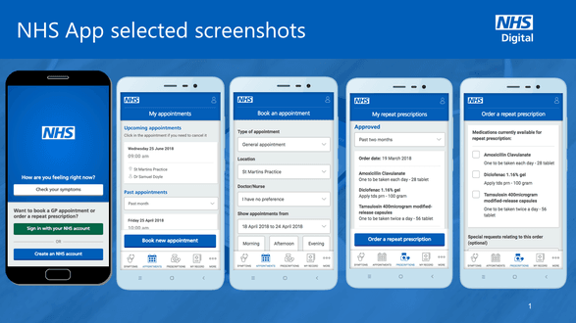
Please note the NHS App is separate to the NHS COVID-19 'Test and Trace' App.

STEP 2:
Once you have downloaded your NHS app you will need to provide some of the following information: your email address, NHS number, name, date of birth and postcode.

STEP 3:
Once you have entered your email address and pressed continue, you are then prompted to create your own password. Your password must have 8 characters or more and 1 capital letter or more. Create your own personal password and then press continue.

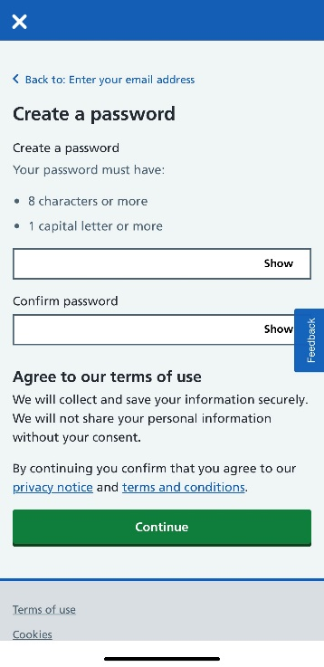
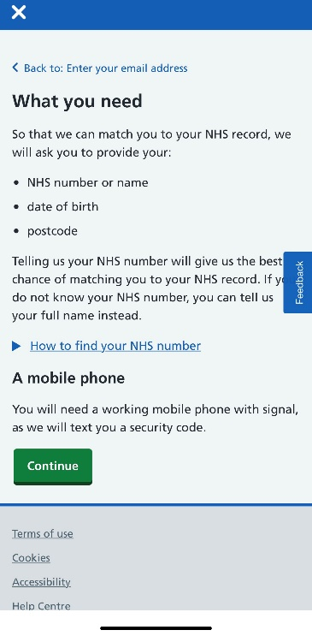
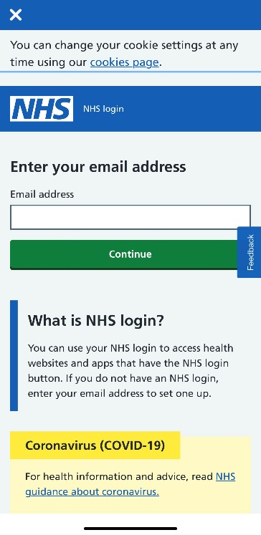

STEP 4:
The NHS app will then send an email to the email address you have given them, just so that you can verify this is your email. There are quite a few security procedures to follow but this is just to keep your NHS account as safe as possible. Once set up, you do not need to keep verifying your identity.

STEP 5:
Go to your email account and open the email you will have received and select 'confirm my email address'. Then go back to your NHS app installation and select 'I have confirmed my email'.
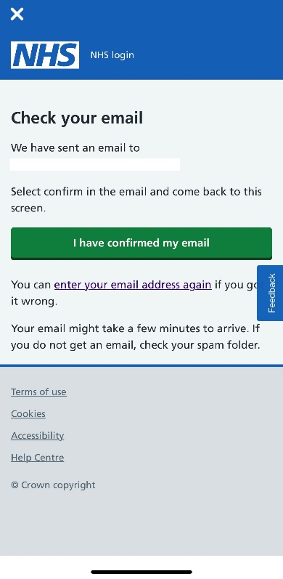

STEP 6:
You will then need to enter your mobile number. The NHS app will then send you a 6 digit security code via text message. The next screen that comes up asks you to submit the 6 digit code they have sent you. Again this is another security procedure to verify your mobile number.
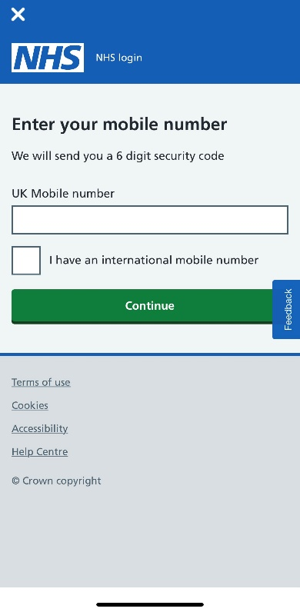

STEP 7:
The next step will ask you to prove your identity. If you have already signed up for online services through the practice (this is a feature called SystmOnline) you can then enter three different codes: Linkage key (often known as Passphrase), ODS code and Account ID. If you have signed up for online services through the practice you should have these details, if not please give us a call and we can send them out to you via email or text. Each code is personalised to each patient, so unfortunately there is not one generic code for all to use.
OR if you do not have these details and are unable to contact us, the NHS app allows you to provide a copy of your photo ID which could include your passport or driving licence. You then submit a photo of your ID through the app and then take a 'video selfie' to prove your face matches the face on the photo. Again, these are just extra security measures that the App is taking to keep all of our data safe. If you do not have photographic ID, do not panic, contact the surgery and we can register you through SystmOnline and provide you with the three codes you need. Please note if we are unable to verify your identity securely over the telephone and we do not feel confident that you are who you say you are, we may ask you to bring some identification to the practice. Again, these are just safety measures put in place to protect patient data.

STEP 8:
Once you have successfully entered either the codes or your photographic ID, the next page asks if you know your NHS number. If you have your number to hand (this could be found on your repeat prescription), please enter it. However, you do NOT need to enter your NHS number if you do not know it, as the app will verify your identity through other methods. If you do NOT have your NHS number click No, continue other way.

STEP 9:
If you do not know your NHS number, the next page asks you for your full name. Enter your details and press continue. The next page asks you to enter your date of birth, please do so and again press continue. You will then need to enter your postcode and press continue.
The App then checks your details against the NHS database and brings up your details, you then need to confirm either
- Yes these are my details
- No these are not my details
- These are my details but some are wrong
We have not yet had any problems reported at this stage so please press confirm your details if correct and press continue.

STEP 10:
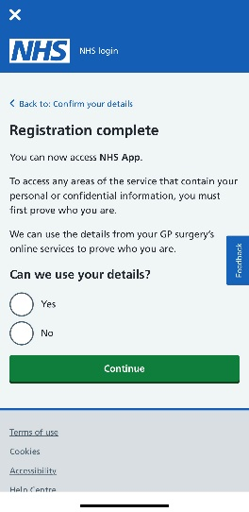
Your registration is complete and you can now access the NHS app. The App then asks if it can use your details to match you to your GP practice, please select YES and continue.

STEP 11:
The App then asks you to accept the conditions of use, please do so and select continue. Your NHS app will then be set up and ready to go. This is what your new NHS App home screen will look like.
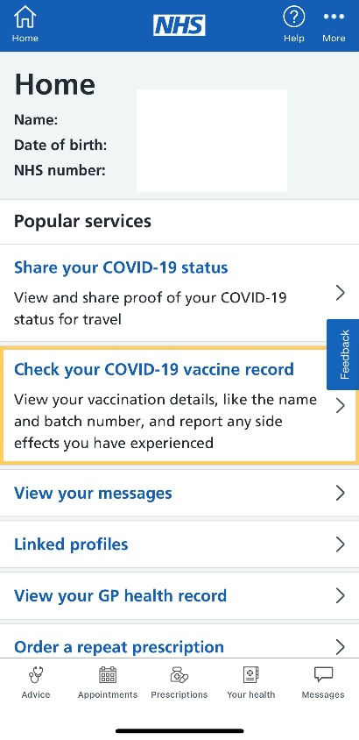

Important Notes:

- Your COVID 19 vaccination status is visible when you have had both vaccinations and at least 5 days after your COVID vaccination

- Your medical records are not automatically visible once you have registered for the NHS app, each practice has their own policy for allowing access to records online. New EU wide Data Protection Regulations came into force on 25th May 2018 and since this time, McKenzie Group Practice is contracted to offer access to 'detailed coded records' from this date (25/5/18) to present ONLINE only. If you wish to access further records you will need to complete a Subject Access Request Form which can be collected at the practice.

